Time Series Analysis:
- Time series: ordered sequence of values of a variable at equally spaced time intervals
- Obtain an understanding of underlying forces in data
- Fit a model and proceed to forecasting
- Time data contains random variation – smoothing and averaging techniques help reveal the underlying trends in data
- Average is a useful estimate for forecasting when there are no trends
- Alternative method: smoothing averaging
- Run sequence plot – recommended first step for analyzing time series
- Box-Jenkins Models, regression, etc.
Things to look for:
- Is data additive or multiplicative? Will affect input to seasonal decomposition function in Python
- What is the period of the data? (Monthly, yearly, daily, etc.)
- Trends
- Seasonality
- Cyclicity
- Irregularity
- Create stationary noise distribution to make future projections
Pandas: seasonal_decompose()
Anomaly Detection:
- Isolation forest
  - Tree based anomaly detection algorithm
- Clustering
  - Clusters of single datapoints can be classified as outliers
  - DBscan, K-means, GMMs
- One-class SVM
  - Captures majority class, classifies extreme values as outliers
- Local outlier factor
  - Works well w/ low dimensionality but breaks down in high dimensions

- Make sure to run these methods only on training set and not testing set to avoid data leakage
- The first three methods can be run in Python, unsure about the fourth – still need to test them out
Dataset: https://www.kaggle.com/datasets/devarajv88/target-dataset?select=sellers.csv
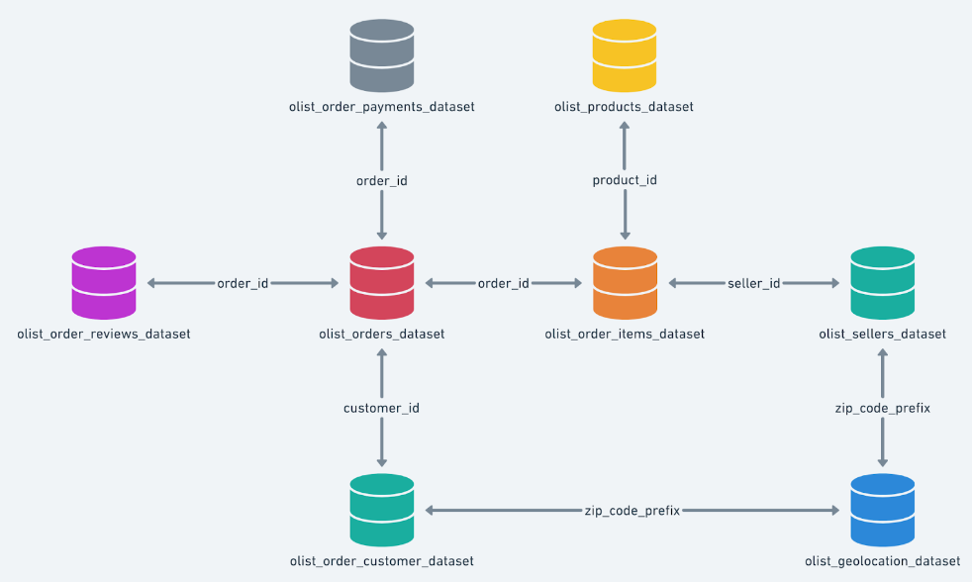
Questions:
- Which customers ordered the most items? What cities did these customers come from? What states did these customers come from?
- What is the distribution of purchases over states?
- On average, how many items did each customer order?
- What was the average amount spent by each customer?
- What product variables correlate to a product selling well?
- What product variables correlate to a product with a higher price?
- What sellers sold the most items? What cities did these sellers come from? What states did these sellers come from?
- On average, how much did each seller earn?
- Did products with low description length sell better?
- Did products sold by sellers in city A sell better than products sold by sellers in city B by a statistically significant amount?
- What was the distribution of orders over each month? What month had the highest number of orders? What month had the lowest number of orders? Is there seasonality to the orders?
- Can we predict which month in the future will have the highest number of orders?
- Do products with more photos sell more?
- What category of products sells the most?
- Given some product, what should its price be?
- Given some product, will it sell well?
Code: https://www.kaggle.com/code/ashukla09/test-notebook
To do:
- Finish writing up code for regression/prediction questions in italics
- Continue playing around with time series data to determine when to use additive/multiplicative models, whether any new information can be gained from resampling by year/day
- Look deeper into anomaly detection methods

